**TMB study group – Meeting 1**

I organize the questions into two parts. The first part is on some statistical background. You are welcome to look up some readings to familiarize with the concepts. I’ll also give a 1000-foot overview in our meeting. However, these concepts are key to understand why and how we are doing what we do.

**Concepts:**

1. What is a hierarchical model?

2. What are random effects and fixed effects?

3. What is a state space model?

4. What is a linear model? Generalized linear model? Generalized linear mixed effect model?

5. What is an additive model? Generalized additive model?

6. Do you recognize this expression? P(data|process, parameters)*P(process|parameters)

If not, check the definition of likelihood function and maximum likelihood

7. What is the difference between likelihood and probability?

8. What is data fitting? Why do we need to do data fitting and how?

9. How do we find a derivative?

10 . What is a normal likelihood? Poisson likelihood?

**Coding**

Check the installation help document for installation stuff.

Check <https://kaskr.github.io/adcomp/Introduction.html> for the structure of TMB, I/O with R and a C++ template.

This is the very first meeting. I’ll give an example for a cpp and R script first. Check the cpp file and R file in Week 1 folder for hints for Question 1.

Question 1:

Calculate the derivative of this complex function

$$f\left(x\right)=-e^{x^{2}}{\left(x+1\right)}^{2}-{\left(sinx-3\right)}^{2}/10$$

Use TMB to recreate this plot.

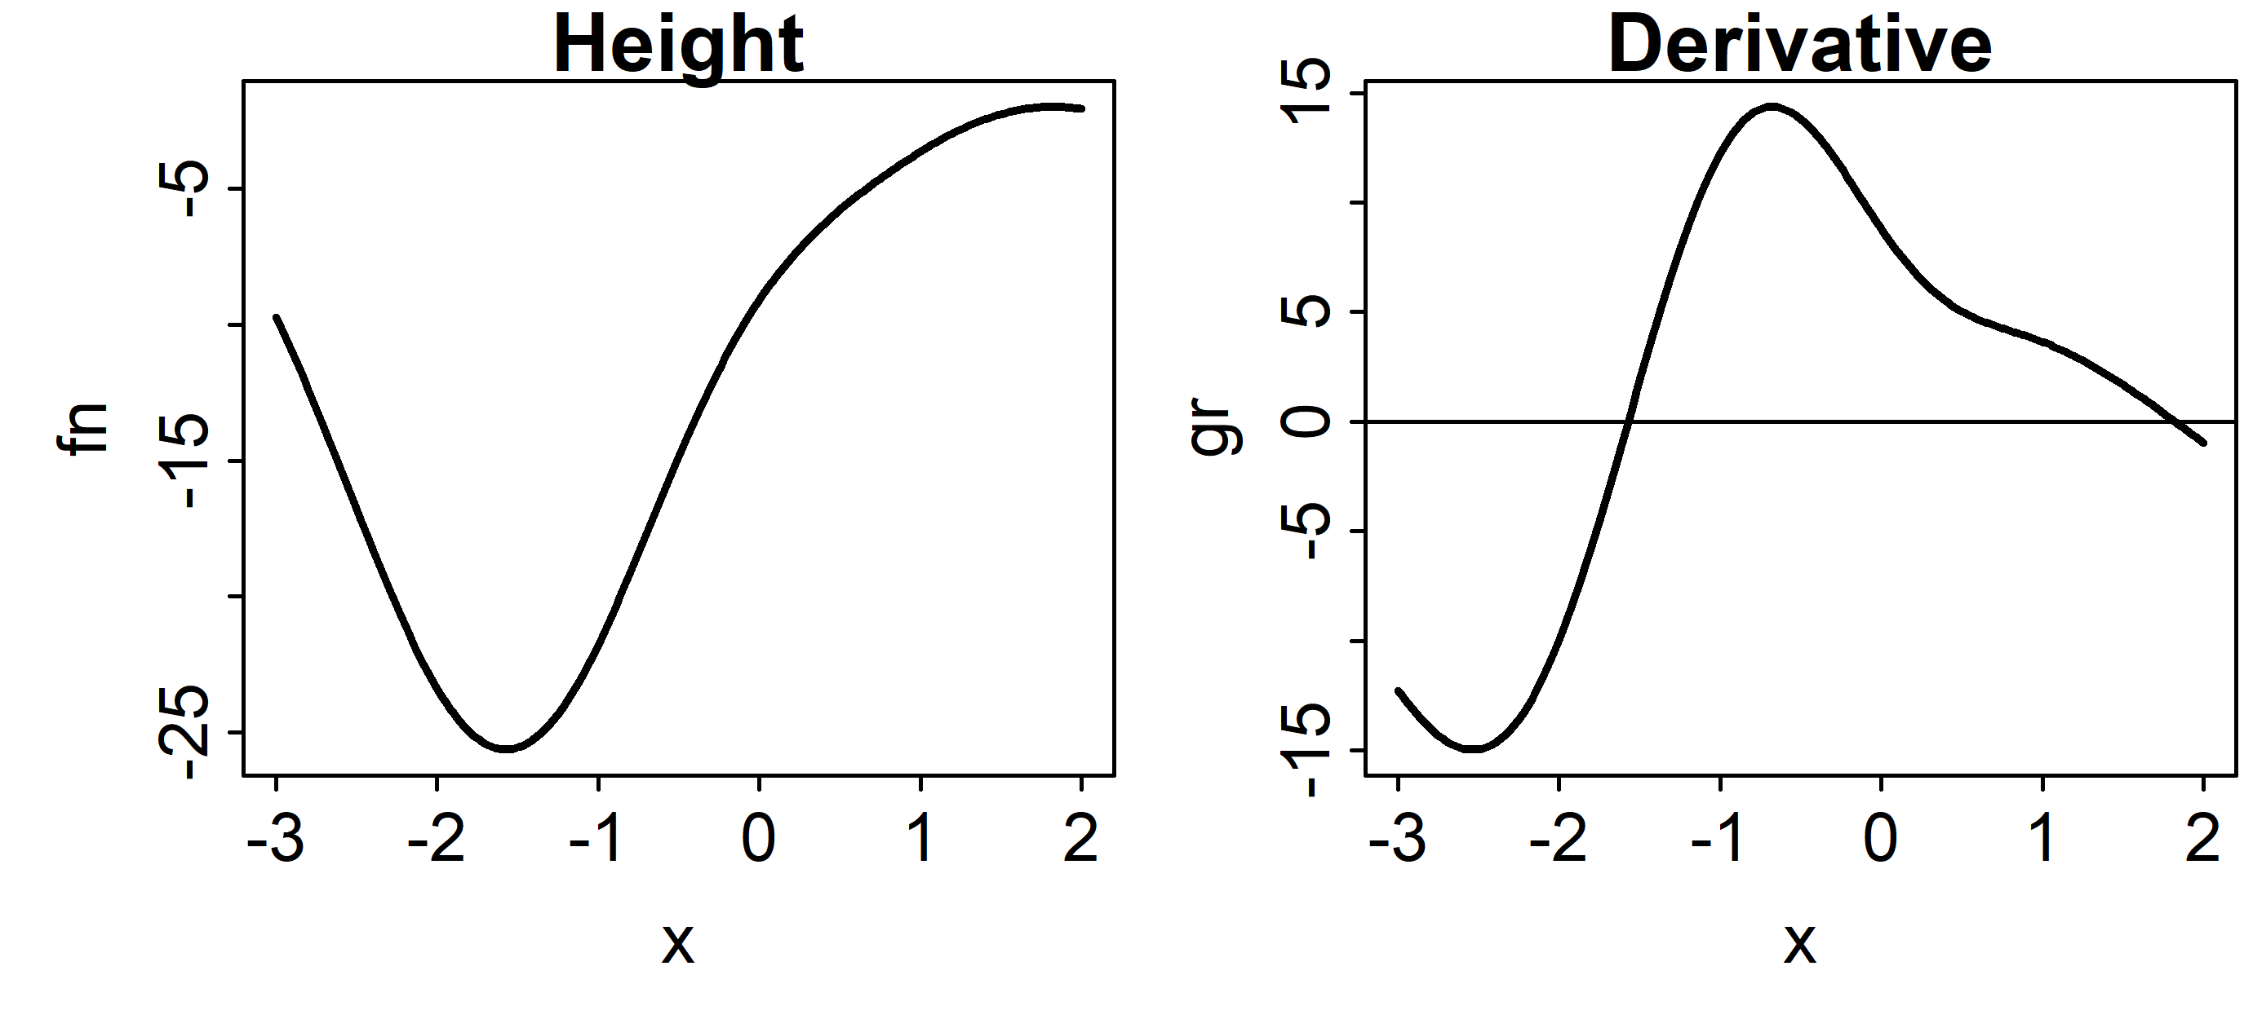

Hint: You need to use a for loop over x in [-3,2]

Question 2:

Look up the probability mass function (pmf) for Poisson likelihood; identify which term are data and which term are parameters.

Take log of the function by hand.

Write out the loglikelihood (nll) for a single data point.

Evaluate the nll for k = 4 and lamda = 5.5. Check answer with dpois(x, lambda, TRUE)

Plot NLL for lambda between 0 and 15

Hint: Use log(factorial(k)) or lgamma(k+1)

Question 3:

Here are your data. Assume a linear model $y=ax+b$, find parameters a and b that minimizes the negative log likelihood (NLL). There are multiple ways using R function (lm), R optimizer with R NLL, R optimizer with TMB NLL.

x **<-** c**(**1.87, 1.96, 1.39, 2.24, 2.33, 2.24, 2.67, 2.47, 1.35, 2.00**)**

y **<-** c**(**2.47, 2.42, 2.2, 2.72, 2.65, 2.5, 2.85, 2.77, 2.28, 2.45**)**

Hint: use nlminb() in R for optimizer.

**Fun reading lists**

These are some applications of TMB to ecological problems. Basically, TMB is just a generalized regression tool to find MLE. Once you have an appropriate model written for your problem, TMB can help finding the parameter estimates.

Spatial (geospatial)

Thorson, James T., et al. "The importance of spatial models for estimating the strength of density dependence." *Ecology* 96.5 (2015): 1202-1212.

Species shifts

Thorson, J. T., Pinsky, M. L. and Ward, E. J. (2016), Model-based inference for estimating shifts in species distribution, area occupied and centre of gravity. Methods Ecol Evol, 7: 990–1002. doi:10.1111/2041-210X.12567

Fisheries stock assessments

Berg, Casper W., and Anders Nielsen. "Accounting for correlated observations in an age-based state-space stock assessment model." *ICES Journal of Marine Science* 73.7 (2016): 1788-1797.

Animal movement

Albertsen, Christoffer Moesgaard, et al. "Fast fitting of non‐Gaussian state‐space models to animal movement data via Template Model Builder." *Ecology* 96.10 (2015): 2598-2604.

Fisheries CPUE standardization

Monnahan, C.C., and I. J. Stewart. "The effect of hook spacing on longline catch rates: Implications for catch rate standardization." *Fisheries Research* 198 (2018): 150-158.

Evolution of fly wings

Houle, David, et al. "Mutation predicts 40 million years of fly wing evolution." *Nature* 548.7668 (2017): 447.